**NAME: JEEVITHA R**

**REG NO: 23BAI1550**

**MONGODB CONNECTION:**

**PRICE RANGE BETWEEN 700 TO 900:**

**package** connection;

**import** com.mongodb.MongoClient;

**import** com.mongodb.client.MongoCollection;

**import** com.mongodb.client.MongoDatabase;

**import** org.bson.Document;

**public** **class** Productquery {

**public** **static** **void** main(String[] args) {

MongoClient mongoClient = **new** MongoClient("localhost", 27017);

MongoDatabase database = mongoClient.getDatabase("vit");

MongoCollection<Document> collection = database.getCollection("products");

Document priceRangeQuery = **new** Document("price", **new** Document("$gte", 700).append("$lte", 900));

**for** (Document doc : collection.find(priceRangeQuery)) {

System.***out***.println(doc.toJson());

}

mongoClient.close();

}

}

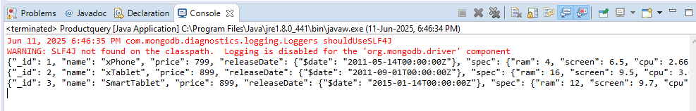

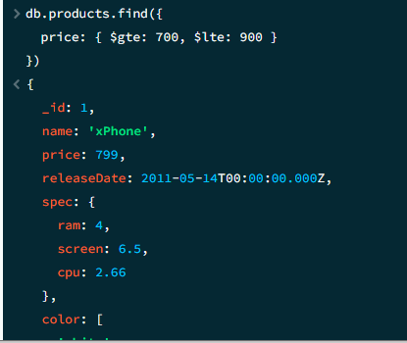

**AVERAGE PRICE:**

**package** connection;

**import** com.mongodb.MongoClient;

**import** com.mongodb.client.MongoCollection;

**import** com.mongodb.client.MongoDatabase;

**import** com.mongodb.client.AggregateIterable;

**import** org.bson.Document;

**import** java.util.Arrays;

**public** **class** averageprice {

**public** **static** **void** main(String[] args) {

MongoClient mongoClient = **new** MongoClient("localhost", 27017);

MongoDatabase database = mongoClient.getDatabase("vit");

MongoCollection<Document> collection = database.getCollection("products");

AggregateIterable<Document> result = collection.aggregate(Arrays.*asList*(

**new** Document("$group", **new** Document("_id", **null**)

.append("averagePrice", **new** Document("$avg", "$price")))

));

**for** (Document doc : result) {

System.***out***.println("average price: " + doc.get("averagePrice"));

}

mongoClient.close();

}

}

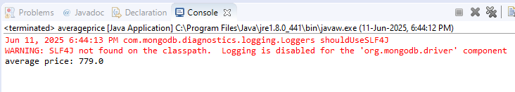

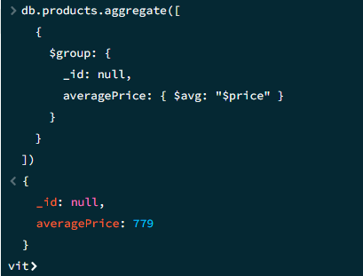

**MAX PRICE IN EACH ITEM:**

**package** connection;

**import** org.bson.Document;

**import** com.mongodb.client.MongoClient;

**import** com.mongodb.client.MongoClients;

**import** com.mongodb.client.MongoCollection;

**import** com.mongodb.client.MongoDatabase;

**import** **static** com.mongodb.client.model.Aggregates.*;

**import** **static** com.mongodb.client.model.Accumulators.*;

**import** **static** com.mongodb.client.model.Sorts.*;

**import** java.util.Arrays;

**public** **class** maxprice{

**public** **static** **void** main(String[] args) {

**try** (MongoClient mongo = MongoClients.*create*("mongodb://localhost:27017")) {

MongoDatabase db = mongo.getDatabase("vit");

MongoCollection<Document> sales = db.getCollection("sales");

sales.aggregate(Arrays.*asList*(

*group*("$item",

*max*("maxPrice", "$price"),

*addToSet*("sizes", "$size")

),

*sort*(*descending*("maxPrice"))

)).forEach((Document doc) -> {

System.***out***.printf("%-10s: $%2d (Sizes: %s)%n",

doc.getString("_id"),

doc.getInteger("maxPrice"),

doc.getList("sizes", String.**class**));

});

}

}

}

